The Power of Communication: Increasing Patron Engagement Through Outreach and Assessment
Mikolaj Wilkª, Gabriela Garcia^{b}, Matthew Frenkel, Ph.D.^{c} , Lindsay Anderberg^{d*}
^{a,b,c,d}Bern Dibner Library, New York University, Brooklyn, New York
^{c}ORCID: 0000-0002-6883-1105
^{d}ORCID: 0000-0002-1943-500X
*landerberg@nyu.edu, 5 MetroTech Center, Brooklyn, NY 11201

To access the published version of this article:

Mikolaj Wilk, Gabriela Garcia, Matthew Frenkel & Lindsay Anderberg (2019) The Power of Communication: Increasing Patron Engagement through Outreach and Assessment, Science & Technology Libraries, DOI: 10.1080/0194262X.2019.1659210

The Power of Communication: Increasing Patron Engagement through Outreach and Assessment

National trends suggest that many library services are under-used due to lack of effective marketing, as opposed to lack of community interest. This paper uses Dibner Library’s instructional workshop program as an example of a low-attendance library offering transformed by assessing a number of communication efforts. In order to tailor outreach to Dibner patrons, librarians tracked patron surveys, Bitly clicks across all forms of digital publicity, and registration and attendance statistics. The resulting increase in engagement shows that customized communication is at the root of successful library programming.

Keywords:
library marketing; outreach; communication; library analytics; library instruction; library workshops; student engagement

Introduction

Over the course of its history, NYU Tandon School of Engineering has experienced a series of seminal shifts, including several name changes. The school’s last independent name, before the affiliation with NYU, was Polytechnic University (Poly). NYU and Poly officially merged in 2014, and Dibner Library joined the NYU Division of Libraries. For the first two years following this merger, Dibner staff focused on revising and improving all library services by extensively weeding the collection, migrating to NYU’s ILS, and re-evaluating the role of reference services. Moreover, our web services librarian, who managed all of the libraries’ print and digital outreach, left Dibner after the merger. No one was hired in her stead, and multiple librarians absorbed her duties. The Dibner librarians felt that in the midst of all these changes, it was important to stay focused on the library's mission to support the teaching and research needs of the faculty and student body at NYU Tandon.
Our library workshop program was a clear place to start: it was already established, so we did not have to create new programming from scratch, and it aligned with our mission and values to teach students transferable skills and get valuable face-to-face time with them to answer questions and sharpen their information and data literacy skills. Tackling this issue required dividing outreach work, and a group of three librarians and one staff member self-identified that they were interested in integrating student engagement into their workloads. A significant component of Dibner’s role in working toward our educational mission was running a series of instructional workshops on topics such as software and research skills.
Throughout the first year in which Dibner Library became part of the NYU Division of Libraries, librarians noted that use of services had declined, including reference assistance, personal consultations, and workshop attendance. Despite this downward trend, we had anecdotal evidence that our student body still valued our services and believed them to be useful and important. When speaking with librarians in various in-person contexts, students were generally unaware of what we offered, sometimes even suggesting that Dibner Library should offer services that already existed. It was clear from these discussions that we needed to rethink how we communicated with patrons so that they could remain informed about library offerings and take advantage of all that Dibner had to offer.
In exploring possible solutions, we found that we were not alone in dealing with communication difficulties. Due to the increasing availability of electronic library resources, academic libraries have been grappling with declining use of reference services and lack of in-person engagement, a trend that has been the subject of numerous studies (Zhang, 2019; ACRL 2015; Black 2016). The simplest answer is that a lack of awareness about reference and instructional services pervades the library world (Robinson 2007). In our internal discussions about improving public service, we came face-to-face with the possibility of removing traditional library offerings, given how under-used they were. However, we decided to focus on improving our communication strategy with our patrons before making decisions about shuttering various reference and instruction services.
One central question drove our research: how does a library make users aware of its services? Over the years, Dibner has employed numerous methods of publicizing library offerings to the school population, including personal emails from librarians, online calendar events, flyers, social media posts, and in-library PA announcements. But which of these methods of communication was most effective at reaching our patrons? We realized that if we were going to improve awareness of our services, we first needed to establish how best to communicate with patrons in order to spread awareness about our instructional workshop program.

Literature Review

Research about community engagement at libraries shows a clear trend: while most libraries offer services and programming that their patrons find valuable and worthwhile, it is a lack of effective outreach and marketing that keeps attendance down. A 2013 study from Pew Research Center reveals the extent of these systematic communication breakdowns, noting that listing events on library websites falls short of the type of digital marketing needed to get patrons’ time and attention, and that a far more expansive, creative strategy is needed to rectify the issue. This communication gap goes both ways—focus groups of librarians expressed widespread concern and frustration about not being able to reach library patrons to help them with their projects and meet their needs. These experiences play out in the statistical data, as well: 31% of library users said they know “little to nothing” about library offerings, even as 80% of them agreed that library reference services and face-to-face time with library staff were “very important” to them (Zickuhr and Purcell, 2013). Though Zickuhr and Purcell focus primarily on public libraries, their data is still highly relevant to understanding how various populations conceive of libraries and the services they provide. Communal interest in libraries remains fairly high, along with a need for better publicity to raise awareness and improve accessibility of programs and in-person reference assistance, which patrons view as essential. A clear trend has unfolded: even with the rise of digital information, most patrons want to attend programming that allows them to engage and connect with their librarians, whom they view as facilitators of experience (Thaler et al, 2015).
Marketing literature reveals that reach and frequency are the most telling consumer statistics, and that tracking these components of the user experience leads to greater impact and increased engagement in the long run (Kamin, 1978). Thus, we identified that quantitative assessment would be our main barometer for tracking the status, progress, and success levels of our experimental communication. Click-throughs, ad impressions, unique visitors, and page views have proven to be accurate criteria for measuring user communication effectiveness (Cheong, de Gregorio, and Kim, 2011). Although these metrics are typically used by businesses to maximize profitability and sell products, we adopted them in order to gain a deeper knowledge about how our patrons were approaching our communication attempts and which methods that they responded to best. A particularly effective method of assessment is surveys, which have been used successfully in many library-related studies. (Thompson, 2018; Dennis, 2012). Surveys allow users to express direct feedback and then watch as incremental changes are made at the library based on their responses.
Jeffrey Lant’s “rule of seven,” shows that people are unlikely to take action or interact with an offering the first time they see or hear about it (Lant, 1989). In order to combat this common roadblock, we turned to cross-media communication methodologies that target a population in multiple, unique ways in order to increase the chance of exposure and interaction with our patrons. A dual approach that combines different types of digital marketing is more likely to reach the intended audience than aggressively pursuing one method (Wakolbinger, Denk, and Oberecker, 2009). Effective digital communication formats include email outreach, listserv advertisement, networking, and social media (Harrington and Li, 2001). Online and print marketing can be braided together, and through careful scheduling and sequencing, have optimal impact (Loda, 2014). Additionally, social media platforms such as Facebook and Twitter have previously been used in academic library outreach and have high potential for reaching patrons. (Ahrony, 2012) These multimedia approaches create space for libraries to customize communication plans in sync with patrons rhythms and needs.
In 2016, a study out of Columbia University Libraries showcased the need for new promotional tactics, focusing specifically on the unique needs of engineering students. Their research examines the ways that academic libraries, and science libraries in particular, can take advantage of digital spaces, gaps in the curriculum, and the structure of the academic calendar in order to boost student engagement (Ransom and Wilfong, 2016). The researchers found success marketing workshops and other library news through opt-in email newsletters using MailChimp and were able to assess open rates and clicks within emails. Engineering students are often early adopters of new technologies, which means that they are an ideal population with which to try out different modes of outreach and reference (Torrence, 2015). Bishop and Owens of University of Nebraska suggest cultivating a “culture of yes” when it comes to trying out different engagement methods in order to make space for experimental communication with students, as long as the approaches are contextualized by clear goals and tracking methods to determine what works (Bishop and Owens, 2018).
The ever-changing role of library faculty and staff means that marketing and communication responsibilities are now integrated into existing workloads, and it is important to make these changes manageable. The best way to prevent employees from feeling overwhelmed is to emphasize that they do not have to have a deep expertise in patron engagement in order to fold aspects of it into their current instruction and programming efforts (Johnson, 2018). University of Minnesota libraries suggests that leadership draft a clear understanding of how the library plans to approach new goals so that all employees know where their efforts can be leveraged most effectively. In addition to focusing on communicating with patrons, it is equally important for faculty and staff to communicate amongst one another. Whether new roles are being created or current ones are being expanded, it is essential for everyone to know what their responsibilities are within the publicity and engagement structure and how they will be expected to participate (Whatley, 2009).
In order to maximize contact with library users, specifically in the context of academic science libraries, it is essential to create a structured outreach plan that tracks digital interaction and tailors programming to the unique scheduling needs of the student population to increase attendance. Given that 80% of American library patrons deeply value in-person library services, reference workshops offered face-to-face can play an immensely important role in the patron experience and can allow libraries to have greater positive impact on the people they serve (Zickuhr and Purcell, 2013). In their research on community engagement, the Online Computer Library Center encourages libraries to build on the valuable relationships between students and library faculty and staff. Given that information access is a solo endeavor for most patrons in the age of Google and Wikipedia, it is crucial for libraries to take advantage of the demand for offline experiences and events, even if they are marketed digitally (Connoway, 2015). If communication with library patrons remains consistent, customized, well-researched, and utilizes cross-media marketing, engagement will follow.

Methodology

The objective of this study was to determine the most effective methods of communication for library workshops. Our approach to communication was two-fold, and was comprised of library outreach efforts and patron feedback. We designed our methodology with the goal of using communication as a vessel to keep patrons informed, thus achieving increased attendance, which was our main measure of success. Current enrollment at NYU Tandon is 5,331 (NYU Tandon, 2018) and total enrollment throughout all NYU schools is 60,513 (NYU, 2018).
Dibner conducted outreach through various media: TV screens, digital calendars (NYU Libraries LibCal and School of Engineering events calendar), flyers throughout the School of Engineering buildings, BluuBeam (a beacon-based bluetooth messaging app), email, social media (Facebook and Twitter), a LibGuide page, Dibner Library website, Dibner Library room reservation page, PA announcements, and word-of-mouth. For both digital and print outreach, Dibner relied on the free hyperlinking shortener Bitly to track user clicks. Unique Bitly links allowed us to track which media patrons were using to view and register for workshops. This data was accessible through the Bitly website. All Bitly links ultimately directed users to the NYU LibCal registration page for the specified workshop.
In order to measure the impact of methods that could not be tracked using Bitly (word-of-mouth and PA announcements) as well as receive feedback from patrons about all methods, we issued paper surveys to attendees at each workshop. We submitted these surveys to the NYU Institutional Review Board, and they were deemed exempt from review. We collected registration numbers via LibCal and recorded attendance numbers using a sign-in sheet at each workshop administered by a library staff member. Based on these measurements, we will refer to three different levels of impact our outreach methods had on patrons throughout this paper. The first level is “reach,” which refers to a Bitly link click. The next level is “interest,” which refers to a patron registering for a workshop. The third level is “engagement,” which refers to a patron attending the workshop.
This study took place over the course of four academic semesters, starting in the spring of 2016 and concluding in the fall of 2017. At the end of each semester, we analyzed the data and took steps to refine both our outreach and feedback approaches. Some of our methodology changed due to circumstances outside our control. These variables occasionally made it more difficult to measure our impact. The following is a more detailed explanation of how we utilized our communication methods during each semester and how and why changes were made.
At the beginning of the study in spring 2016, we established several methods of outreach. We scheduled 13 workshops for the semester, one for each week and broke down responsibilities among three librarians and one staff member. One librarian was responsible for creating weekly digital content: emails, blog posts, calendar postings and LibGuide, each containing a unique Bitly. A weekly email (See appendix 1) containing a short workshop description was sent to a professor, who then emailed all graduate students. A linked image to each blog post appeared on the Dibner Library website homepage. A Tandon School of Engineering calendar event posting for the upcoming workshop appeared approximately one week prior to the workshop, while a LibGuide listing all workshops for the semester was updated weekly. Another librarian was responsible weekly flyers with an image, description, and unique Bitly. These flyers were posted in and outside the cafeteria, in the library building lobby, and within departments in places with the most student traffic. A third librarian was responsible for social media and the TV screen in the library. Two days prior to each workshop, a description was posted to Facebook and then posted again on the day of the workshop. These posts were mirrored on Dibner’s Twitter account. Each week a presentation slide with the current week’s workshop information and a unique Bitly ran on the library’s TV screen, located in the atrium. A staff member was responsible for running the Bluu Beam application message. Patrons who had downloaded the bluetooth-enabled phone application received these messages when walking close enough to the beacons in the library. Finally, a library PA announcement was made about 5-10 minutes prior to each workshop by the circulation desk manager. A librarian maintained sign-in sheets and administered paper surveys to attendees.
In the fall of 2016, we chose to make several changes to our outreach methods. At this point during the year, the library hired a new staff member who became mainly responsible for all print and digital content except social media. Therefore, we chose to offer more workshops, totaling 23 for the semester. In order to market this fuller schedule, we facilitated email blasts to be sent out every two weeks and we began to use three different channels. Email 1 was sent to all graduate students using the same methodology as the prior semester. Email 2 was sent to all students who had signed up for a library Mailchimp email list. Email 3 was sent by liaison librarians to their respective departments requesting that administrators and professors pass on the email to their students. Each of these three emails had unique Bitly links so that we could study the differences (See appendix 1).
In summer 2016, NYU Libraries adopted the Dibner Library website and made it into a single webpage. On this new page, blog post links were located at the bottom of the Dibner library sub-page, but the content and frequency of blog postings remained unchanged from spring 2016. In an attempt to offset the low visibility of the blog posts on the new site, we put a Bitly hyperlink to the workshops LibGuide further up on the web page. The LibGuide was updated 2-3 weeks prior to each workshop as well as the School of Engineering event calendar. In order to publicize more topics at one time, we created a more efficient flyer marketing scheme that did not require hanging flyers on a weekly basis. Instead, we hung flyers at the beginning of the semester that included a listing of all the workshops for that semester. We felt this was more effective than only featuring one workshop each week, since patrons may have been interested in other topics. We applied this same strategy to our TV screen, which displayed the semester-long schedule for our many different workshop topics. Furthermore, during fall welcome week we created print bookmarks which had the workshop schedule for that semester. Our social media, PA announcements, and surveys were unchanged from the prior semester. BluuBeam was discontinued due to lack of use in the prior semester.
During spring 2017, we offered 26 workshops and made a few other changes and refinements. Since NYU Tandon changed its policy on mass emails, and the professor from the previous two semesters was no longer able to forward our emails, we now relied on NYU Tandon’s IT department to send biweekly emails to graduate students. Email 2 and 3 were unchanged except that our Mailchimp subscribers had grown throughout the fall. Our LibGuide and School of Engineering calendar posts remained the same, aside from making all of our Bitly links clickable at the start of the semester so that patrons could access all the information about our workshops at any point. Our blog posts, social media, TV screen, and PA announcements were all unchanged. Our print flyers were also unchanged, except that we included large posters of the workshop schedule for the semester and posted more of the flyers around the library. After tracking patron responses the previous two semesters, we revised our survey questions to solicit patron feedback about our new email scheme. In order to better understand how patrons preferred to be reached, we also added a question asking how they would like to hear about workshops.
For fall 2017, we offered 25 workshops. Our marketing approaches were all working well and yielding the feedback and results that we were seeking. Therefore, the only significant change we made was eliminating our Mailchimp emails. Our reasons for this were two-fold: the Mailchimp emails were the least successful out of our three email channels, and we wanted to avoid redundancy and over-marketing. More information about this refinement is provided in the Results and Discussion section of this paper.
The nature of our study meant that there were significant variables, some of which were out of our control, such as changes to university-wide policies. Our methodology was ever-changing in an effort to adapt to what we saw our patrons responding to. Our refinements were largely practical and proactive, and though they did not adhere to a rigorous research protocol, we did utilize a consistent structure.

Results and Discussion

This section will be broken down into three parts. First, we will discuss the most effective modes of communication. In the second and third parts, we will identify anomalies in the data that relate to workshop content and timing.

Determining Effective Modes of Communication

In order to evaluate communication effectiveness, we focused primarily on two data collection methods: paper surveys and Bitly clicks. The surveys asked attendees how they heard about a workshop and how they would prefer to hear about workshops in the future. The Bitly clicks allowed us to gauge our reach, and, combined with survey data, helped us refine our methods over time.
In both the spring and fall of 2016 we asked the same survey question: “How did you hear about this workshop?” We provided fourteen different options, including a write-in “other” option. Figure 1 shows the top five survey responses, along with the total number of responses that we received each semester. Four out of the top five attendee responses were the same across these semesters: Dibner Library website, email from a professor, flyers in the library, and PA announcements.
Figure 1 shows that “email from a professor” was the most effective outreach method in spring 2016, while the second most popular choice was “other.” However, 22 out of 30 respondents who selected “other” indicated that they, too, heard about the workshop through an email, but from sources other than a professor. Therefore, we introduced a more refined email scheme (outlined in the methodology section) starting in the fall 2016 semester. In the spring of 2017, we again asked attendees how they heard about a given workshop, but expanded the response options so that attendees could select from three different email sources: professor, library, and department (see appendix 2). These new choices allowed survey respondents to be more specific about the types of emails that reached them.
The spring 2017 survey asked attendees how they would prefer to hear about upcoming workshops moving forward. Over 60% of 271 attendees responded that they wanted to receive some form of email either from the library (48%) or from their department (13%). During the fall of 2017, the survey questions remained the same, and we received even more responses: 372. Once again, email proved to be the most popular channel of communication. Over two-thirds of respondents said they had heard about the workshops through an email and preferred to be reached by email from their department, a professor, or the library. As shown in figure 2, survey respondents overwhelmingly favored emails directly from Dibner Library, which we determined was the most effective mode of communication from our four semesters of data.

Figure 1. Top 5 survey responses: How did you hear about this workshop?
Figure 2. Survey Responses: How would you like to hear about future workshops?

The Bitly click data verified that the surveys accurately captured patron behavior. Figure 3 shows the total Bitly clicks from each semester broken down into total email and non-email categories. Emails accounted for the majority of clicks during all semesters. Additionally, the percentage of total clicks represented by email increased each semester, as shown in Figure 3. We believe that email reach grew in part due to our refinements, which included improved email formatting, and consistency of email outreach.

Figure 3. Percentage of clicks from emails vs non-email
Figure 4. Percentage of clicks from emails 1, 2, 3 and non-email

Closer analysis reveals that Bitly click numbers varied across the three email methods we employed. There was an observable increase in the number of clicks coming from department emails (email 3) and Mailchimp (email 2). However, our graduate student email (email 1) saw a 40% decrease in clicks between the fall 2016 and spring 2017 semesters. We believe that the decrease in engagement with email 1 can be attributed to the changes in university policy regarding mass emails. Due to these changes, the NYU Tandon web team sent email 1 in spring 2017. This shift removed the more personalized touch inherent in receiving emails directly from a professor, making email 1 less effective than previous semesters. Meanwhile, email 3, which was sent from either a professor or administrator specific to each student’s department, increased in clicks, suggesting that the sender of emails was a crucial component for click numbers. Despite these fluctuations with email 1 and email 3, they remained our most effective communication methods during both semesters. (See figure 4)
When we established the three-channel email structure, we chose to include Mailchimp to see if it made a difference in clicks. We started with 18 subscribers at the beginning of September 2016 and exponentially grew to 407 subscribers by our final email campaign at the beginning of April 2017. As the number of subscribers increased, the email open rate consistently remained above 70% throughout the spring 2017 semester. Despite our expanded subscriber pool for email 2, the amount of patrons it reached was miniscule compared to emails 1 and 3. Thus, we chose to eliminate email 2 from our communications after the spring 2017 semester so as not to interfere with our more effective email methods.
As email emerged as the most successful method of communication, it became clear that a few of our methods were not reaching patrons with the same efficiency. Our Facebook and Twitter posts were not getting many clicks, and our survey results confirmed that respondents did not prefer to be reached through these social media channels. In the spring and fall of 2016 only 1 survey respondent indicated that they found out about a workshop via social media. In the updated survey used in the spring and fall of 2017, social media was one of the least preferred outreach methods (See Figure 2). In spring 2017, 42 survey respondents, about 15%, chose social media as a preferred method; in fall 2017 this number dropped to only 32, about 9%. Among those same survey respondents, only 6 in each semester said they found out about the workshops through social media. Since social media turned out to not be among our most effective modes of communication, we decided not to pursue investing more time in expanding it, especially since we knew that it would take significant work to increase our follower count and maintain our social media presence.
Flyers, posters, other print methods, and our TV screens had mixed results. At first, they seemed to be somewhat effective in reaching patrons. In the first three semesters, flyers around campus were among the top 5 responses on our surveys, but in fall 2017 only 9 respondents (2%) chose this option. However, in the latter two semesters, survey results indicated that flyers, posters, and TV screens were all among the least preferred methods of communication. Despite these low statistics, we knew anecdotally that some patrons had been seeing our flyers and posters. Also among survey respondents’ least preferred methods of communication were our postings in the Tandon School of Engineering events calendar. A total of 9 survey respondents (less than 2%) from spring and fall 2017 indicated that they had found out about the workshops from the School of Engineering events calendar.
By fall 2017, almost 90% of our clicks came directly from emails (see figure 3). This data, together with our survey responses, indicated that patrons preferred to get information about workshops directly from the library, not through an alternate website or calendar. However, we decided to maintain a handful of our other communication methods to supplement emails, including calendar posts, social media, and flyers. Even though these methods were not as popular as emails, we did not want to narrow our communication to be entirely email-dependent given the research about multimedia marketing and the possibility that other channels were, in fact, reaching some patrons.

Evaluating interest and evolution of workshop topics

Our research was not only useful for determining how to reach out to our patron population; it also informed the workshop topics we offered. Through our survey, we asked attendees which workshop topics they would be most likely to attend and included a write-in option for patrons to suggest topics. In addition to these direct suggestions, we also analyzed the number of Bitly clicks (reach), number of registrants (interest), and the number of attendees (engagement) for each workshop offering, which helped us identify topics that were of most interest to our patron population. In evaluating student interest and the role of workshop topics, we looked at three sets of data: topic requests, topic categories, and the most successful workshop topics offered.
We measured student interest in potential workshop topics by including the survey question “I would be interested in attending workshops that cover (check all that apply).” We then provided a list for attendees to choose from and a write-in option. When comparing the spring 2016 and fall 2017 surveys, the top five requests remained the same: MatLab, data visualization, quantitative analysis software, data management, and 3D printing software. The write-in option gave us good insight into the topics students wanted to attend outside of their academic courses, though occasionally these requests were not within the library’s mission. For example, we received requests for topics such as operating systems, parallel processing, and Linux, which fit within the teaching domain of academic departments at the engineering school, rather than topics that were within the library’s domain of research support. Since topic requests between the first two semesters of the study were fairly consistent, we removed this question when we revised the survey for spring 2017.
In order to provide a comprehensive view of the different themes and topics we offered, we sorted workshops for the four semesters into two general categories: information literacy and Data Services/software. Information literacy workshops encompassed instruction that primarily focused on database searching, or research skills. Data Services/software workshops were those taught by a member of the NYU Libraries Data Services department, or workshops that featured tutorials on how to use specific software. Although some workshops fell into both categories, they were coded according to which category they fit best, so that each workshop belonged to only one classification.

Figure 5. Percentage of workshops by category

Over the course of the four semesters, we slowly increased the number of Data Services workshops in direct response to survey feedback. Understandably, the engineering students at NYU Tandon requested workshops related to engineering software and data management. However, even as we expanded Data Services options through more software-based offerings, we still deeply valued the role of information literacy workshops and continued to integrate them into our schedule to ensure that our students knew how to apply their research and software skills.
In addition to collecting survey responses from workshop attendees, we analyzed reach, interest, and engagement through other methods: reach was evaluated by counting Bitly clicks, interest was monitored through registration numbers, and engagement was tracked through attendance data. The reach for all workshops, as measured in total Bitly clicks, jumped significantly between the first and second semesters of our study (993 in Spring 2016; 2351 in Fall 2016) and then plateaued in the third and fourth semesters (1667 in Spring 2017; 1588 in Fall 2017). Despite the total Bitly clicks decreasing from fall 2016 to spring 2017, we saw an increase in workshop attendance, which we believe was due to our more efficient communication methods. Click counts helped us gauge the relative reach of each communication method, and also proved useful in determining the interest level for any given workshop. More clicks implied curiosity, or even enthusiasm, for a workshop topic. If a patron not only clicked the link, but took the time to register, it was a clear sign of interest. We also examined follow-through by comparing how many students registered with the number of students who actually attended the workshop. Although high attendance was an important goal, we recognized that it was variable depending on many external factors, such as conflicting university events, classes, midterms, and weather. Counting clicks, registrants, and attendees informed us about which workshop offerings our students were prioritizing.
As we added new Data Services workshops, we saw an increase in the number of Bitly clicks for those topics. Information literacy workshops still remained of strong interest to our patrons, receiving some of the highest click and attendance numbers. Students showed strong interest in workshops that helped them understand how to use, manage, or analyze data. Novelty also turned out to be an important factor in successful workshops--the first time a topic was offered, clicks, registration, and attendance were typically higher. This trend stayed consistent over the course of all four semesters. For example, our new “Get a Patent” workshop in spring 2016 received the highest click count and the third highest attendance of the semester. “Introduction to LaTex,” introduced in fall 2016 had the highest attendance for the semester, and “Data Extraction & Management Using Python,” which also debuted in fall 2016, had the highest registration and second highest attendance for the semester. Workshops had higher interest and engagement if they were scheduled in sync with relevant university events, such as our career-related workshops that coincided with the fall and spring career fairs. Topic utility, novelty, and scheduling were essential determinants of student interest and engagement.

Examining the effects of timing on workshop attendance

As noted earlier, a number of external factors had the potential to bring down attendance, even for workshops with the highest interest and reach. We knew that the days and times of our workshops would be important, given how many other scheduling needs our student body juggles, including course schedules, university events, and exam periods. Dibner Library occupancy counts helped us determine the days and times when the highest number of patrons were in the library, and therefore not attending classes or other events. Tuesday, Wednesday and Thursday were the highest occupied days during the semester, particularly between 1:00 PM and 5:00 PM. Thus, we scheduled our fall 2016 workshops on Wednesdays and Thursdays and alternated between 11:00 AM and 3:00 PM start times. Since workshops typically lasted 1-2 hours, these start times ensured that workshops would be over by 1:00 PM and 5:00 PM, when students were least likely to have conflicts. We found that Thursdays did not yield as many attendees, so for the spring 2017 semester we switched to weekly time slots on Tuesdays at 3:00 PM and Wednesdays 11:00 AM and 3:00 PM. This schedule was built with our patrons in mind so that timing would not be a significant barrier to attendance.
Workshops scheduled at the start of each semester tended to have higher turnout, regardless of topic. An example of this pattern is our career resources workshop, which was one of the only workshops that we held during each of the four semesters of the study. Due to its early semester placement, this workshop had consistently high attendance. In contrast, we scheduled our patent workshop series at the beginning of the semester in spring 2016, and then duplicated the series toward the end of the semester in spring 2017. Despite every other aspect of the series remaining unchanged, placing the patent workshops at the end of semester had a detrimental effect on attendance, suggesting that earlier scheduling is more successful than mid-to-late semester placement. This pattern is likely due to the increased workload that students face as the semester progresses, giving them less time to engage in library programming. Even our communication refinements could not offset this timing.

Figure 6. Average attendance per week in semester

We averaged the attendance per week for the two fall and spring semesters, respectively, in order to see how attendance changed over time (see figure 6). Although attendance numbers had peaks and valleys over the course of the semesters, the overall trend was downward. We also averaged workshop registrants and attendance per month, shown in figure 7. This figure also demonstrates that as the spring semesters progressed, both registrant and attendance numbers decreased, with the lowest numbers in April. During fall semesters, this pattern varied slightly, with registrants and attendance numbers dipping in October, followed by an increase in November.

Figure 7. Average registrants & attendance per month

High-interest topics can offset the mid-to-late semester dip in interest and engagement. In response to student demand, we added a Python-related workshop to the schedule in fall 2016. In spring 2017, we strategically scheduled this workshop in the middle of the semester to see if it would still perform well. Despite its mid-semester placement, this workshop was unusually successful, which shows that a topic of high interest can still do well during a time of increased academic focus. If a Python workshop had been scheduled earlier in the semester, it is likely that attendance would have been even higher. This anomaly suggests that higher interest topics can be strategically scheduled during parts of the semester when students are less engaged with library programming in order to keep numbers consistent.

Figure 8. Total attendance per semester

As our study progressed, our communication refinements became more consistent, customized, and effective, and kept patrons informed about our offerings. We stopped hearing as many comments from our patrons that they were unaware of library workshops. Figure 8 shows that total attendance numbers increased significantly over the course of the four semesters of the study, even considering that more workshops were held per semester (see figure 8). During fall 2016, we offered ten additional workshops than we had the previous semester, but only gained 53 attendees. The following semester we increased our workshop offerings by 3, but our attendance increased by 125 patrons. In fall 2017, despite offering one less workshop than the prior semester, we still received 60 more attendees on top of the prior semester’s gain for an average of 16 attendees per workshop. Before the study began, in fall 2015, we averaged only 8.66 attendees per workshop. Thus, by the end of our study, workshop attendance had nearly doubled. Moreover, pre-study registration was 10.09 patrons per workshop, while post-study, we saw a jump to 24.88 registrants per workshop. This data tells us that our effort to keep our patrons aware of our offerings, regardless of whether they ended up attending or not, was successful.

Conclusion

Our communication research significantly improved our ability to connect with our patrons and serve their needs. Our approach for this study--the two-way street of communication through outreach and surveys--helped us to learn more about our patrons, how best to communicate with them, what topics and content interest them, and how to optimize our scheduling to best accommodate their needs. These efforts translated to more registrants and attendees over time. Though the limitations and variables of our study were real, this upward trend in engagement shows that the changes we made to our communication did have an impact.
Since we initiated the communication study, over 1,000 attendees had the opportunity to learn new skills and learn about various aspects of information literacy and resources provided by the library that they might not otherwise have known about. Though this study took place at an academic engineering library, the communication principles explored in this paper can be applied to all academic libraries and even public libraries. Based on our research, we recommend the following steps in order to increase reach, interest, and engagement:

Step 1: Assessment

- Employ a diverse set of trackable communication methods
- Monitor clicks, attendance, and registration rates to determine what kind of programming is of interest to your community
- Track library occupancy rates
- Identify times when patrons are most likely to have conflicts (such as exam periods)
- Survey patrons about their preferred channels of communication and provide multiple opportunities for them to request specific types of instruction or programming

Step 2: Action

- Consistently reach out to patrons using the communication style(s) that they respond to best. If mass emails are not possible at your library, consider using a listserv service such as Mailchimp in order to build a subscriber list.
- Build programming around the topics that are most relevant to your patrons and may align with other events in the community
- Schedule workshops and programs in concert with the unique rhythm of the patron population, picking start and end times in which they have proven availability
- Continue to survey patrons so that the library can always be adapting to their needs

Our research shows that there is strong interest in library services and programming when communication strategies are tailored to the library community. Refined communications help to spread awareness about library services and increase engagement. Each body of patrons can be reached when librarians are consistently soliciting feedback about specific communication preferences and using that feedback to make large- and small-scale changes that ultimately expand and improve the library experience.

References

Aharony, N. 2012. Facebook Use In Libraries: An Exploratory Analysis. Aslib Proceedings 64 (4): 358-372. https://doi.org/10.1108/00012531211244725
Black, S. 2016. Psychosocial Reasons Why Patrons Avoid Seeking Help from Librarians: A Literature Review. Reference Librarian 57 (1): 35–56. https://doi.org/10.1080/02763877.2015.1096227.Vin
Cheong, Y., F. de Gregorio, and K. Kim. 2011. The Power of Reach and Frequency In the Age of Digital Advertising. Journal of Advertising Research 50 (4): 403–15. https://doi.org/10.2501/s0021849910091555.
Connaway, L.S. 2015. The Library in the Life of the User : Engaging with People Where They Live and Learn. Dublin, Ohio: OCLC Research.
Davis, R. C. 2016. Hackathons for Libraries and Librarians. Behavioral and Social Sciences Librarian. https://doi.org/10.1080/01639269.2016.1208561.
Dennis, M. 2012. Outreach Initiatives in Academic Libraries, 2009-2011. Reference Services Review 40 (3): 368-383. http://dx.doi.org/10.1108/00907321211254643.
Harrington, D. L., and X. Li. 2001. Spinning an Academic Web Community: Measuring Marketing Effectiveness. Journal of Academic Librarianship 27 (3): 199–207. https://doi.org/10.1016/S0099-1333(01)00181-1.
Johnson, A. M. 2018. Connections, Conversations, and Visibility How the Work of Academic Reference and Liaison Librarians Is Evolving. Reference & User Services Quarterly 58 (2): 91–102. https://doi.org/10.5860/rusq.58.2.6929.
Kamin, H. 1978. Advertising Reach and Frequency. Journal of Advertising Research 18 (1): 21–25.
Lant, J. 1989. Let’s Not Call It Marketing. Nonprofit World 7 (4): 18–20.
La Place, C., Jordan, S., Lande, M., & Weiner, S. 2018. Engineering Students Rapidly Learning at Hackathon Events. American Society for Engineering Education. https://doi.org/10.18260/1-2--28260.
Loda, M. D. 2014. Suggesting a More Effective Way to Use the Promotional Mix in Services. Services Marketing Quarterly 35 (4): 304–20. https://doi.org/10.1080/15332969.2014.946875.
New York University. 2018a. Fast Facts: Student Enrollment,” Accessed August 10, 2019. https://engineering.nyu.edu/about/fast-facts.
———. 2018b. “NYU at a Glance,” Accessed August 10, 2019. https://www.nyu.edu/about/news-publications/nyu-at-a-glance.html.
Owens, T. M., and K. Bishop. 2017. ‘Let’s Try It!’: Library Outreach in a Culture of Yes. Public Services Quarterly 14 (1): 75–82. https://doi.org/10.1080/15228959.2017.1411861.
Ransom, E., and K. Wilfong. 2016. A New Approach to Marketing and Outreach for Engineering Libraries. In ASEE Annual Conference & Exposition. American Society for Engineering Education. https://doi.org/10.18260/p.26374.
Robinson, C. M., and P. Reid. 2007. Do Academic Enquiry Services Scare Students? Reference Services Review 35 (3): 405–24. https://doi.org/10.1108/00907320710774283.
Thaler, M., C. Barber, T. Batchvarova, A.Bhalodia, D. Broz, M. Burke-Vigeland, A. Colyer, et al. 2015. The Post-Book Librarian? https://www.gensler.com/research-insight/gensler-research-institute/librarians-on-libraries.
Thompson, S. M. 2018. Assessment’s Role in Building Student Support to Facilitate Change. Performance Measurement and Metrics 19 (2): 101–10. https://doi.org/10.1108/PMM-10-2017-0050.
Torrence, M. 2015. Services and Resources to Engineers: A Case Study of Outreach and Marketing, Assessment, and Future Directions in a Research Library. Issues in Science and Technology Librarianship Paper 170. https://doi.org/10.5062/F43776Q0.
Vinyard, M., C Mullally, and J. B. Colvin. 2017. Why Do Students Seek Help in an Age of DIY? Using a Qualitative Approach to Look Beyond Statistics. Reference and User Services Quarterly 56 (4) https://doi.org/10.5860/rusq.56.4.
Wakolbinger, L. M., M. Denk, and K. Oberecker. 2009. The Effectiveness of Combining Online and Print Advertisements. Journal of Advertising Research 49 (3): 360–72. https://doi.org/10.2501/s0021849909090436.
Whatley, K. 2009. New Roles of Liaison Librarians: A Liaison’s Perspective. Research Library Issues, no. 265: 29–32. https://doi.org/10.29242/rli.265.6.
Winning, T., V. Skinner, A. Kinnell, G. Townsend, G. Svensäter, M. Rohlin, and J. Davies. 2012. The Influence of Two PBL Curricular Contexts on First-Year Students’ Understandings of PBL, Approaches to Learning and Outcomes. https://doi.org/10.1007/978-94-007-2515-7_5.
Zhang, S. 2019. Evolving and Unchanged: How a Series of Workshops at an Academic Library Reflects Its Roles and Values. PNLA Quarterly 83 (1/2): 11–13.
Zickuhr, K., and K. Purcell. 2013. Library Services in the Digital Age Patrons Embrace New Technologies-and Would Welcome More. But Many Still Want Printed Books to Hold Their Central Place. Pew Research Center. Accessed August 10, 2019. http://libraries.pewinternet.org/2013/01/22/Library-services/.

Appendix 1: Emails

An example of an email from Spring 2016:
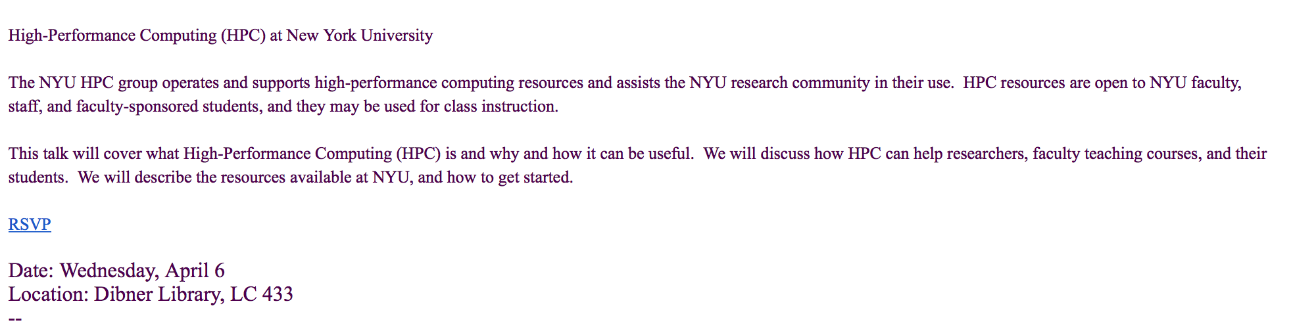
An example of an email from Fall 2016:
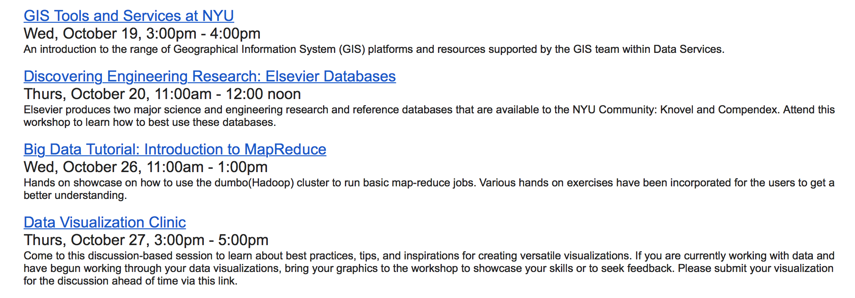
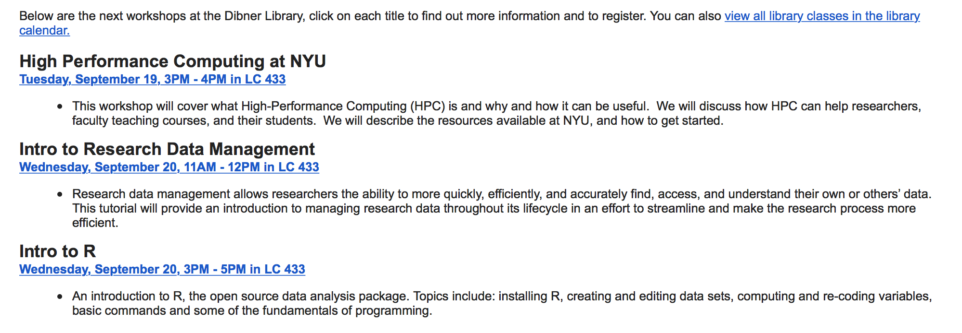
An example of an email from Spring 2017 & Fall 2017:
Appendix 2: Surveys

Spring 2016 and Fall 2016 Spring 2017 and Fall 2017

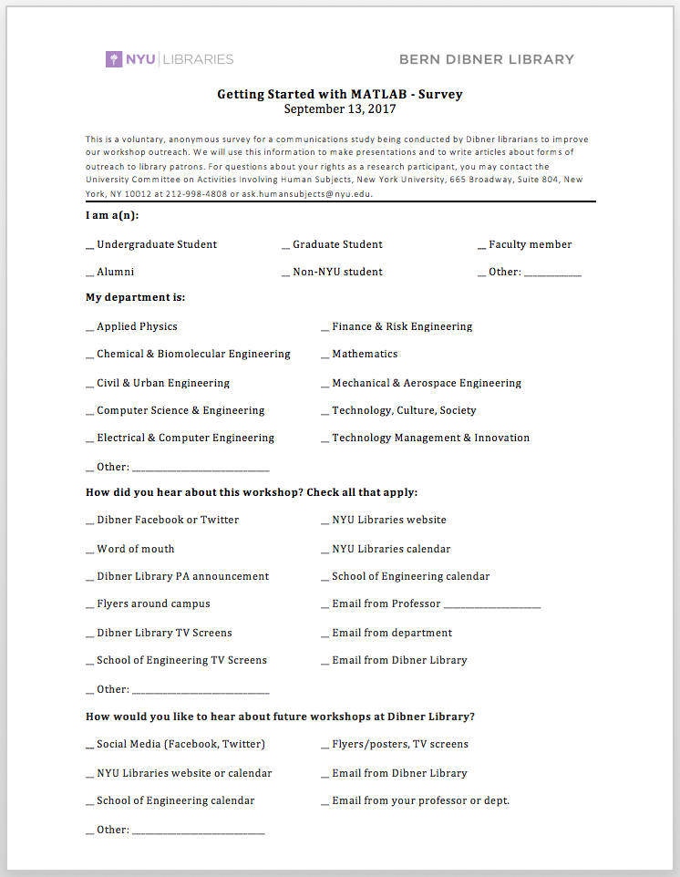
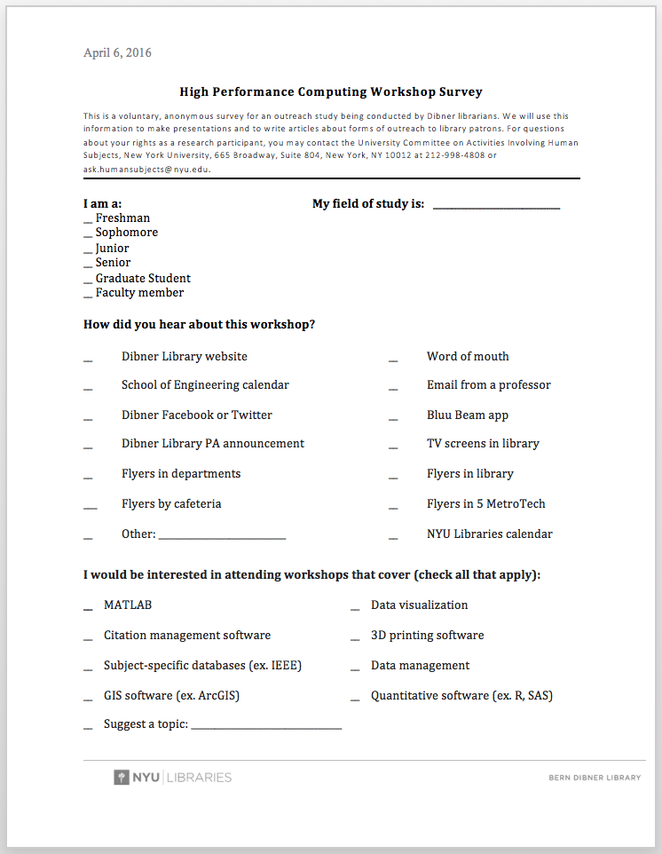

Appendix 3: Communication Methods

Spring 2016
Communication Method | Description | Bitly
Email | Weekly emails to graduate students | Yes
Website blog posts | Blog post on Dibner website was made about one week prior to workshop and linked from the website homepage | Yes
SoE events calendar | Event posting was made about one week prior to workshop | Yes
LibGuide | Each week the link to the following week’s workshop was made clickable | Yes
Flyers | Weekly flyers for each workshop | Yes
Social media posts | Facebook posts appeared 2 days prior to a workshop and then again on the day of the workshop. These posts were mirrored to Twitter | Yes
TV Screen | Weekly TV screen for each workshop | Yes
Bluu Beam application | Weekly messages about workshops were set up to go out to students who had downloaded the app, had bluetooth enabled, and were within range of our bluetooth beacons | Yes
PA Announcement | Announcements were made 5-10 minutes before workshops began | No
Survey | Surveys were given to all workshop attendees | No

Fall 2016
Communication Method | Description | Bitly
Email | Emails were sent every 2 weeks  Email 1: Email to all graduate students  Email 2: Mailchimp email list  Email 3: Liaison librarian emails to departments/professors | Yes
Website blog posts | Blog posts on Dibner library sub-page of NYU Libraries website appeared about one week prior to workshop | Yes
SoE events calendar | Event posting were made about 2-3 weeks prior to workshop | Yes
LibGuide | A link to the upcoming workshops was made clickable about 2-3 weeks in advance | Yes
Flyers & other print | Flyers containing the complete workshop schedule were distributed and placed in various locations at the beginning of the semester. Bookmarks and notebooks were given out at the beginning of the semester with a list of workshop topics | Yes
Social media posts | Facebook posts appeared 2 days prior to a workshop and then again on the day of the workshop. These posts were mirrored to Twitter | Yes
TV Screen | Semester long TV screen displayed workshop topics for the entire semester | Yes
PA Announcement | Announcements were made 5-10 minutes before workshops began | No
Survey | Surveys were given to all workshop attendees | No

Spring 2017 & Fall 2017
Communication Method | Description | Bitly
Email | Emails were sent every 2 weeks  Email 1: Emails to all graduate students  Email 2: Mailchimp email list (Only done in Spring 2017)  Email 3: Liaison librarian emails to departments/professors | Yes
Website blog posts | Blog posts on Dibner library sub-page of NYU Libraries website appeared about one week prior to workshop | Yes
SoE events calendar | Event posting were made at the start of the semester | Yes
LibGuide | A link to all upcoming workshops was made clickable at the start of the semester | Yes
Flyers & other print | Flyers containing the complete workshop schedule were distributed and placed in various locations at the beginning of the semester. Poster sized versions were also made and posted in a few places around the library. | Yes
Social media posts | Facebook posts appeared 2 days prior to a workshop and then again on the day of the workshop. These posts were mirrored to Twitter | Yes
TV Screen | Semester long TV screen displayed workshop topics for the entire semester | Yes
PA Announcement | Announcements were made 5-10 minutes before workshops began | No
Survey | Surveys were given to all workshop attendees | No

