Just Walk Out Technology (JWO)/ AmazonGo
Link: https://justwalkout.com/

Introduction
Today, timing really matters, especially when shopping. The days when grocery stores profited from impulse buys made during long lines seem to have already passed. However, the ongoing workforce crisis and low operating margins have taken a toll on grocery stores (The State of Waiting in Line Report, 2023, p.4). Recent research indicates that about 68% of customers (two out of five) are likely to abandon a physical line when wait times feel excessive. This pattern suggests that long lines can directly translate into lost sales opportunities and diminished customer satisfaction. Therefore, introduction of new technologies was not only highly anticipated by businesses seeking to retain customers and secure a competitive advantage but also by customers who value their time and sought a better overall experience. With introduction in 2017 Just Walk Out Technology (JWO) in Amazon Go stores has revolutionized the way people shop. It offered fully automated stores with a self-service/checkout concept.
This technology is a great example of how various IoT systems are seamlessly integrated into a unified solution.
In this paper the proposed IoT system embraces two definitions offered by Internet Architecture Board (IAB) and IEEE Communications Magazine. In particular, IAB defined the IoT as “a set of large numbers of embedded devices, which provides communication services based on the Internet Protocols” (Sharma et al., 2019, p.31). In the case of Just Walk Out Technology (JWO), this definition is reflected in the network of embedded devices within the shelves that communicate through Internet protocols. The other definition offered by IEEE states that the IoT system through “Machine-to-Machine (M2M) communications <enable> interaction between objects and applications in the cloud” (ibid, p.32). This definition explains the framework within which operates JWO, where each object (product on shelf) is uniquely identified and tracked, and then stored on the cloud. This is a good example of the M2M communication, where machines interact and exchange data without human intervention.
This topic represents a practical example of how several IoT systems can form a network of connected devices and contribute to user convenience and business operational efficiency. From a social perspective, this technology reduces the need for human labor in routine tasks and facilitates the reallocation of human resources. From a technological perspective, JWO shows how different technological devices and IoT systems can be integrated into one cohesive and advanced automated system. Such integration helps us anticipate and address the technological challenges which can be hidden in a complex "multi-vendor ecosystem" of IoT systems (Sharma, 2018, p.46). From an industrial perspective, this system optimizes the daily processes and reduces the mistakes that can be made by humans.
Yet, despite the promising nature of JWO futuristic technology, there are still some challenges that can't be ignored. These complex systems, it turns out, are not as autonomous as they appear on the surface. Therefore, the goal of this paper is not only to explore the technological complexity of the JWO system, discuss its future implementation, but also acknowledge the challenges we face when using it.

2. Historical Overview
The technological progress that accelerated throughout the 20th century laid the foundation for a new paradigm: unmanned systems, where everything is interconnected through RFID tags, sensors (such as weight-sensing shelves/carts and shelf cameras that track inventory), and digital payment accounts. This has created a “network of physical objects” that seamlessly communicate and exchange information via various protocols (Sharma, 2018, p.30).
The backbone of this development lies in the convention of RFID (Radio Frequency Identification) tags, which were originally developed during World War II for military purposes to help radar systems differentiate British aircraft from German ones (Foster et al., 2005, p.1). However, it took almost a decade for RFID technology to be adopted by the general users in the anti-theft system like EAS (Electronic Article Surveillance) (Plichta, 2004). While the initial technology was very basic by today’s standards, it laid the foundation for the development of advanced technologies based on the automatic identification of objects without physical contact.
The early 20th century also saw significant advancements in semiconductor technologies, which, unlike wireless communication technologies like RFID tags, were designed to detect changes in physical conditions — such as temperature, pressure, and motion — and convert them into data. The integration of sensors in automated systems began in aviation, where on-board sensors were used to “record engine data and perform fault detection” ( Jaw & Garg, 2005, p.8). While these sensors helped detect engine events and manage engine-airframe communication, the system was not perfect. During real-time experiments conducted by NASA, the system failed to detect and “accommodate both large-magnitude (or hard) and small-magnitude (or soft) failures” (ibid. p.8).
Everything changed when Analog-to-Digital Converter (ADC) was introduced which enabled the convert analog signal into binary code (Verhelst, 2005, p.67). The adaptation of new technology was driven by reducing the size of the device and its ability to capture the incoming signal “without loss of information” even if the physical signal bandwidth is high (ibid p.67). The adaptation of ADC was a crucial step in development and adaptation of IoT systems, where accurate and efficient data collection and processing are crucial.

3. Sensors
Simply walk in, pick up your item, and leave — we take care of the rest. While this may sound like a futuristic promise from a company renowned for its convenience, it’s a practical application of IoT technology, specifically involving various types of sensors (Hyken, 2018). In the case of JWO technology, optical sensors (cameras), weight sensors (or load cells), and RFID sensors are used. Then collected data merged into a unified multisensor fusion system, which pairs “measurement with tracks” (Stubberud, 1998, p.62). As a result, the retail system achieves more accurate tracking and management of inventory.

3.1. Sensors (cameras)
The facility ceilings range from 1,800 to 2,100 square feet are equipped with hundreds of advanced depth-sensing cameras (Clark, 2018). The technology used in these cameras combine different types of sensors to capture three-dimensional (3D) images of the store. In particular, the cameras have Time-of-Flight (ToF) sensors and structured light sensors (U.S. Patent No 10679177; Coldewey, 2018).
Structured light systems can create three - dimensional (3D) images using only one optical image sensor (Xiong et al., 2017, p.55). Unlike traditional optical image sensors, which capture two-dimensional (2D) images by transforming “photons into electrical signals”, structured light systems use a different approach (Hu et al., 2023). In these systems, a CMOS (Complementary Metal-Oxide-Semiconductor) image sensor captures a light pattern projected onto surfaces, which creates a grid of dots (Image 1) (ibid, 2023). When the surface is irregular, its “geometric shape <...> distorts the projected structured-light pattern” on the grid (Geng, 2011, p.131). By analyzing these distortions, the system can estimate the depths of the objects.
In addition to structured light systems, Amazon Go also uses Time-of-Flight (ToF) sensors in their cameras. As the name suggests, ToF sensors transmit a light pulse (actually, illuminate the entire scene with light) and measure the time it takes for the light to travel to the object and return to the sensor (Image 2) (Seiter, 2013, p. 240). It is important to note that for real-time performance, the JWO system uses indirect Time-of-Flight (iToF) sensors. In these sensors, “every pixel independently measures the distance to an object” by recording changes in the light wavelength (Bamji et al., 2022).
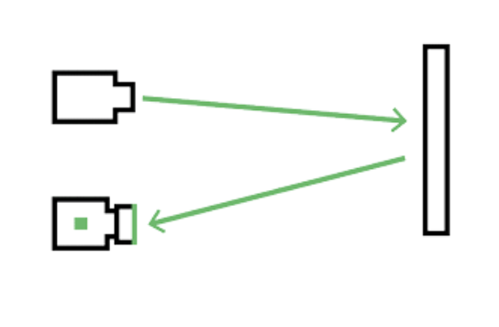
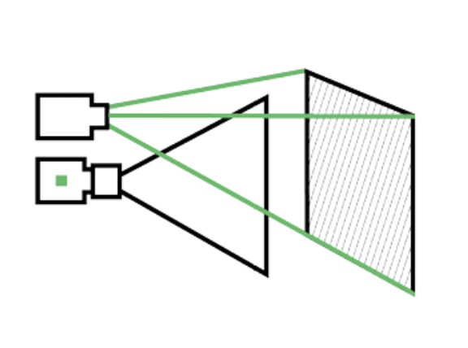
Image 1. Structured light technology Image 2. Time-of-Flight technology

3.1.1. Data Processing
The information regarding the data processing for Amazon Go's depth-sensing cameras is not publicly available, so we can make assumptions based on how similar cameras work. The captured data is initially compressed and processed on-chip (Popp et al., 2012). This System-on-Chip (SoC) operation includes tasks such as raw data to pixel data conversion and analog-to-digital conversion (ADC). Then, the data is sent off-chip to a separated processing unit (coarse-grained reconfigurable image stream processor — CRISP), where it is further processed by reconfigurable stage processing elements (RSPEs), each designed for specific operations (Chien et al., 2015, p.133). Then, the data is sent to the sensor fusion system, which creates a more “unified picture of the system <...> from diverse inter-related datasets” (Chatzichristos et al, 2022). It also produces more accurate results by combining information from different sensors, rather than relying solely on individual ones.

3.1.2. Edge Computing Analysis
The CRISP processor operates in an edge computing setup, where data is processed closer to the source. This allows for complex (real-time) image detection, handling large data sizes while maintaining high-definition quality (Chen et al., 2008). Moreover, processing data near the edge "reduces the bandwidth consumption," as less raw data is transmitted, which also improves overall response time — especially important for detecting when an item is picked up or moved (Hu et al., 2023, p.20). This method is more suitable for ultra-large datasets (ubiquitous computing), as it reduces latency compared to a fully centralized approach where all data is analyzed in the cloud (Image 3) (Chien et al., 2015, p.130).
While edge computing provides unquestionable benefits for complex systems, such as sufficient bandwidth and low latency, it also introduces new security challenges. Due to their weaker computational power, edge devices are more vulnerable to certain attacks that might be, for example, less effective against desktop computers (Ahmed et al., p.4238). Moreover, the different devices used in the JWO system brings additional risks. Any of them could potentially fail or even be accessed by unauthorized users (Singh, 2024, p.21). Thus, these systems need to be carefully managed and regularly updated.


Sensors

CRISP

RSPE
Morphology operations

RSPE
Data access
RSPE
Mathematics functions
RSPE
Logical operations

Local system
ADC
on-chip
(off-chip)
Camera
Edge

Sensor Data Fusion

Data From Other Sensors

Data From Other Sensors

Server
Image 3. Data processing and storage flow for JWO camera technology. Source: Designed by Author

3.2. Smart Inventory Sensors

3.2.1. Weight Sensors (Load Cells)
The load cell sensors used to track inventory by “computing the weight of items and determining the location of items placed on or removed from shelves” (Lin et al., 2022). Precision in measurement is achieved through the use of a strain gauge (electric resistor) that measures deformation when force is applied (Bogrekci et al., 2017). Then the physical force is converted into an electrical signal, which is used to determine the weight of the object.

3.2.2. RFID tags
Another type of sensor that is used in JWO systems are Radio-frequency identification (RFID) tags, “which enables smart shelves and generates real-time statistics about the item location and stock” (Lin et al., 2022). The system has two main components: the “passive” tag and the reader device. The reader sends out energy to power the tag. The tag, which consists of a simple antenna and a silicon chip, sends and receives data when it's close to the reader (Want, 2004).

3.2.3. Edge Computing Analysis
The load cells work in tandem with the RFID tags, enabling the JMO system to simultaneously validate the item and its weight (Mundada et al., 2024). Consequently, a multi-sensor fusion system has been introduced to combine the information received from various sensors (Gross, 2019). This framework relies on an edge computing system that processes heterogeneous data generated from these sensors, facilitating deeper and faster real-time inventory monitoring (Tsanousa et al., 2022). However, before reaching the edge, data from load cells must be converted from analog to digital format through an amplifier, presumably the HX711 module. Then, the data is sent to the microcontroller, where “the weight of items and the total number of pieces in the inventory are calculated” (Mansor et al., 2023. p.14). Afterward, the data is sent to the sensor fusion system (Image 4).
The RFID tags are used for short-range communication, requiring multiple virtual readers to collect the raw data and determine the position of the items (Tsanousa et al., 2022). This collected data is sent to a coordinating processor, such as a Reader Coordinator (RC), which gathers the RSSI (Received Signal Strength Indication) values of the tags (Li et al., 2022). The RC then filters this data (validating and reducing duplicates), groups it, and stores it in a local cache before forwarding it to the sensor fusion system (Su et al., 2007).

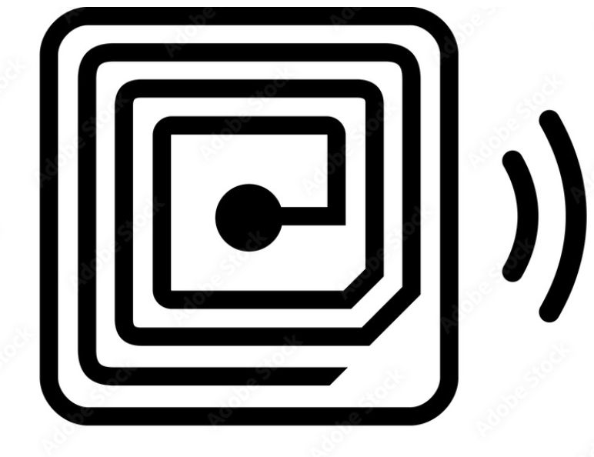


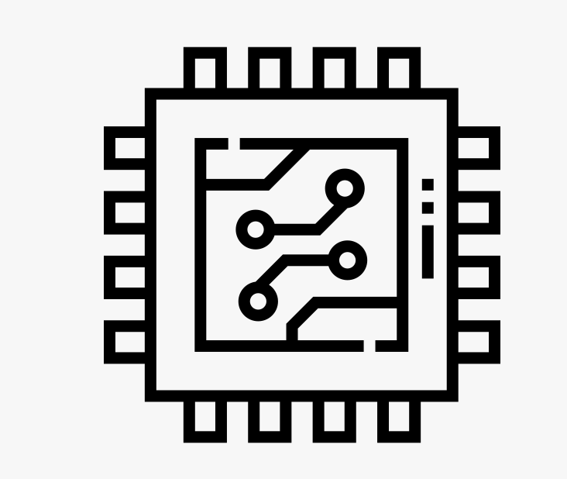
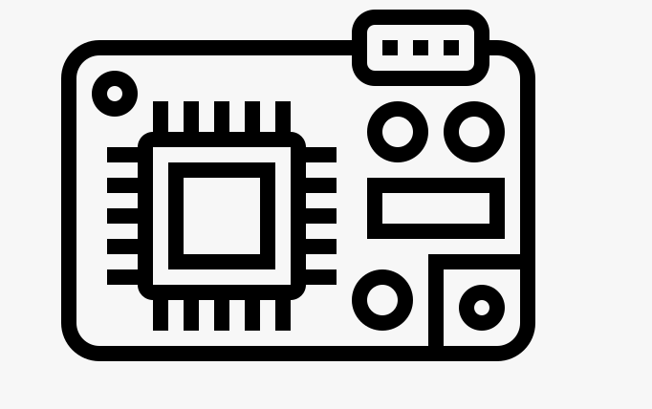

Load Cell
RFID Tag

Coordinating processor (RC)
Local system
HX711 module
Microcontroller

Load Cell system
Sensor Data Fusion

Server

Image 4. Data Flow Diagram for Smart Inventory Sensors. Source: Designed by Author

3.3. Sensors Fusion System
The implementation of data sensor fusion has facilitated more robust real-time data processing, which is crucial to the JWO concept. Moreover, it addresses several problems at once, such as timely data collection (as data from different sensing devices can be collected with varying latency). Additionally, heterogeneous data has another challenge, as it's quality may vary across different nodes (Li et al., 2022). Data fusion helps with this issue, as it adjusts data from various sources to ensure greater consistency. This approach is useful in scenarios where the system must recognize multiple actions simultaneously. However, there are some potential risks. For example, poor incoming data quality that could impact the overall results. Another is reliance on a single point for workload management, which can introduce additional vulnerabilities.
However, this system comes with some potential risks. For example, poor incoming data quality that could impact the overall results. Another is reliance on a single point for workload management, which can introduce additional vulnerabilities.

4. Interface
In terms of sensing modalities, the autonomous system of Amazon Go does not provide a direct interface between the user and the system. Instead, the interaction is initiated through indirect (off-device) inputs from the user (customer), where the system interprets actions like picking up or placing items without requiring explicit input (Wasinger & Wahlster, 2006, p.297). These interactions, often described as “extra-gestures”, are detected through a combination of sensors, including weight-based load cells and visual tracking systems (Wasinger et al., 2005, p.300). The cameras, using technologies like depth sensing and structured light, capture user interactions and track items in real-time without manual input from the shopper. This method of human-computer interaction is based on machine learning technology, which is “learn and adapt according to practical experience” (Türegün, 2019, p.91). In other words, the system is not only trained to recognize specific inputs, but it improves over time as processes more data. For example, initial extra-gesture events included “put down” or “pick up,” but over time, the system adapts to more nuanced behaviors. For example, when customers return one item and pick up another (Wasinger & Wahlster, 2006, p.302). The combination of data collected from different sensors makes the machine learning algorithm more effective, especially in accurately detecting users’ gestures.
Undoubtedly, the system significantly reduces cognitive load on users compared to traditional retail interactions. Still there are practical challenges associated with this type of engagement. Since the system relies solely on the real-time operation of multiple sensors, any delay or error in one sensor can create discrepancies in detecting certain actions. For example, if a customer's hand moves too quickly when reaching for an item, the cameras might struggle to accurately “identify a holding or non-holding hand” (Tran et al, 2020). As a result, this could potentially lead to incorrect interpretation of the customer’s actions, such as errors in billing. Another factor is the error produced by the load cells, which can mistakenly identify a product. For example, in the case of soft drinks, “items often weigh similarly,” as a result, the system may incorrectly signal that another item was picked up (Ruiz et al., 2019, p.519). Another significant drawback related to external factors, such as liquids spills, which can impact load cells accuracy and reliability (ibid, p.519). Moreover, certain issues are more complex and may not be suitable for a solely machine learning approach, requiring a human-in-the-loop. In order for a system to learn effectively, the problem must have a “certain degree of repeatability,” which may not always be the case (Türegün, 2019, p.93). Additionally, the output of the system always relies on mathematical calculations, which sometimes lack ethical considerations. Therefore, in unique instances, human interaction becomes a necessity for the system.

4.1. Interaction
The technologies used in Amazon Go rely heavily on various types of sensors that replicate human sensory experiences, primarily vision and surface sensation. Vision is facilitated by cameras, and the sense of touch is “replicated” by load cells and RFID tags. Although each sensor individually may not enable context awareness, the fusion of simultaneous inputs “creates an output that is greater than the sum of its parts” (Karimi, 2019). This integration enables the system to interpret complex behaviors, such as when a customer picks up or puts down an item, effectively mimicking human perception. However, in an environment where there is no direct input from users, the IoT system must “read” human actions “as a string of characters” and, based on that, perform some analysis (Wasinger et al., 2005, p.300). This interpretation can sometimes lead to incorrect conclusions, resulting in potential errors.
Simply sharing data and performing computations does not allow the system to “perform the logical analysis” necessary for making decisions (Vermesan et al., 2020, p.86). What truly makes the system intelligent, enabling it to simulate aspects of human perception, is the integrated AI, which “incorporates reasoning and decision-making skills into IoT, leading to smart functioning” (Pramanik et al., 2018, p.20). The AI helps interpret user actions based on data captured from multimodal sensors and adapts the sensing data to the situation, adding “human-like intelligence” to the IoT system (ibid, 2018, p.6).
Unquestionably, AI in IoT broadens the system's sensing capabilities, transforming it from mere automation into a cognitive (“thinking”) technology that processes information in real time and responds appropriately to detected actions and behaviors. This intelligent system senses the environment around the user without requiring direct input, thereby reducing cognitive load and enhancing user’s shopping experience across two dimensions: cognitive and sensory/emotional (Hoyer et al., 2022). These dimensions closely align with Hartson's framework of affordance, which combines various aspects of interaction to support users in performing specific tasks (Hartson, 2003, p.316). In this framework, Hartson distinguishes four types of affordance: cognitive, physical, sensory, and functional (ibid, p.323). Each type explains how users interact with the system, which in turn forms their overall experience.
The system operates fully autonomously, without any direct user input, and it eliminates the need to process information manually. However, this increases significantly the cognitive value (or cognitive affordance) of the experience. Moreover, the combination of a multimodal sensor creates an environment where users can act naturally without direct interaction with the system. This setup supports the user's intuitive behavior and makes shopping feel effortlessly. As a result, it facilitates the physical affordance of the Amazon Go stores. The sensory affordance relies on indirect user input (tactile and/or gestures) and provides “a critical supportive role” for physical and cognitive affordances that enrich the user’s experience through natural interaction with the system (ibid, p.322). Functionality affordance "provides the usefulness of user actions" by creating a straightforward setting that ensures the shopping process aligns with user intentions — shopping without the need for traditional checkout procedures.
However, along with its strengths, it is important to acknowledge system limitations, which help harness the full potential of intelligent IoT systems. While the system provides a seamless user experience, it may have flaws in physical affordance and incorrectly interpret indirect user inputs, such as gestures, which can vary “across different cultures and individuals” (Padmaja et al., 2024, p.400). Another significant limitation arises in situations involving multiple individuals, where overlapping gestures could be potentially misinterpreted by the system (ibid, p.400). Moreover, in the context where passive interaction predominates, cognitive affordance may experience some limitations, as users don't have much control over the system. The lack of user awareness regarding their engagement with the system may raise concerns about user consent. For many individuals, this system may raise the sense of uncertainty about how their actions are being monitored and interpreted.

5. Network
The M2M communication in Amazon Go relies on wireless visual sensor networks (WVSNs), which consist of depth-sensing cameras and wireless sensor networks (WSNs) that include load cells and RFID tags (Wang et al., 2021). WVSNs enhance the functionality of WSNs by integrating cameras into sensor nodes, which allow for the recording and processing of images in real time (Wang et al., 2021). The entire network consists of multiple sensor nodes, each equipped with its own processing unit- controllers with programmable logic units (PLUs). This structure allows each node to capture and analyze data independently before transmitting it to a central system. The flexibility of PLUs enables the system to adapt to different functionalities, such as object detection or motion tracking, directly at the node level.
Once the data is processed locally at each sensor node and fused, it is transmitted to the central processing units (CPUs) through various protocols, one of which is the Constrained Application Protocol (CoAP). It is particularly effective for low-rate traffic transmission and “enables the management of IoT sessions” (Herrero, 2022, p.11).
This architecture creates a “star cluster of devices,” where IoT gateways facilitate end-to-end IP connectivity within a Wireless Local Area Network (WLAN) (Vermesan et al., 2022, p.106). The gateway serves as a crucial bridge that connects heterogeneous devices and facilitates seamless communication between the sensor nodes and the central system. Specifically, it converts messages into a unified format “at different levels of the layered architecture” (Herrero, 2022, p.28). In the case of the Amazon Go system, the gateway “translates both physical and link layer frames,” which is helpful for communication across various protocols, such as the wired connections of load cells and the wireless connections of RFID tags (ibid).
As a result, the assets in the Amazon Go store — namely the physical products available for purchase — are seamlessly integrated into this complex IoT system. This connectivity helps with real-time tracking and inventory management (Upadrista, 2021, p. 35).

5.1. Security and Vulnerabilities
The intelligent IoT system used in Amazon Go technology heavily relies on various edge devices, making the system more complex and, as a result, vulnerable to physical, software, and network attacks.
In general, threats can occur at any layer of the system — sensing, data transmission, communication, or within the information network (Alam, 2017, p.318). Some vulnerabilities are closely related to the design of the sensing nodes themselves, since they have different capabilities and encryption standards. For example, some edge devices like load cells and RFID tags have limited processing power. This constraint negatively affects the devices’ encryption capabilities, leading to less robust forms of security. The absence of necessary encryption can also be attributed to the need for real-time data processing, which requires more resources. Consequently, the wireless nodes may be more vulnerable to various attacks, such as “eavesdropping and spoofing attacks” (or Man-in-the-Middle) (Milenkovic, 2020, p.156). Thus, it is recommended to use robust MAC-based authentication mechanisms, which are based on a shared secret authentication key (ibid, p.173). These algorithms must be efficient to prevent delays in data processing by low-power nodes. Additionally, security barriers such as firewalls or containers can be used within the network. Firewalls help filter traffic and containers provide isolated environments for applications to run. The operating systems usually manage containers separately, which ensures that a compromised node does not affect the entire system (ibid, p.156).
The complexity of the Amazon Go system, characterized by its multi-layer architecture, has increased the potential surface for both software and hardware attacks. The nature of software attacks may target hardware vulnerabilities by exploiting communication interfaces such as WiFi or Bluetooth to alter the physical components of the system (Polychronou et al., 2021, p.2). Additionally, software attacks can target the system itself, seeking to breach data security. These attacks often employ methods like code injection, where an attacker gains physical access to the device and the data it collects. To mitigate this risk, it is recommended to “use encryption while downloading software updates” (Alam, 2017, p. 320). Another important aspect is to ensure that the system is secured against “unauthorized access or any changes” (Milenkovic, 2020, p.156). These measures can be implemented by restricting connections or downloads from “unsolicited or unauthenticated software” during system maintenance (ibid). Additionally, establishing a Root of Trust (RoT) ensures that the code undergoes all necessary authenticity checks prior to execution (ibid, p.177).
No system is entirely safe from physical attacks, especially in locations like retail stores where devices are exposed to public access, including Amazon Go. The physical attacks could involve replacing an authentic node with a fraudulent one or causing physical damage to critical components. Even slight damage to a few load cells could compromise the entire system. Such attacks can be mitigated by implementing security monitoring to track who accesses the store and detect suspicious activities. Moreover, tamper detection mechanisms, such as tamper-resistant enclosures and physical unclonable functions (PUFs), will make physical attacks more difficult to execute (Immler et al, 2019, p. 53).
Preservation of privacy is another important consideration in fully automated retail stores like Amazon Go, where extensive surveillance systems are in place (Milenkovic, 2020, p.155). In cases like these, users have no control over the collection of their personal data. This leads to a situation where shoppers become “objects of information rather than subjects of communication” (Pan, 2019, p.40). The data collected by Amazon Go, including purchasing habits and biometric information, raises awareness about potential misuse and unauthorized access. Undoubtedly, it's a challenging task to balance the ease of purchase with the protection of personal privacy - and it's one that calls for the government to step in and establish a regulatory framework.

6. Implementation
The retail industry is often characterized as oligopolistic, with strong intra-competition between existing players vying for customers. Historically, the combination of low operating margins and elevated labor expenses create an environment for technological advancements. Additionally, the increasing demand for a customer-centric approach with personalized promotions and recommendations has “redefin[ed] the customer experience” and introduced new solutions like the Amazon Go system (Weber et al., 2019). Unsurprisingly, with its customer-oriented business model and pioneering technology adaptation, Amazon fits seamlessly into this paradigm. Moreover, its extensive resources for advanced innovation, including IoT systems, and leading status as a research and development (R&D) firm contribute significantly to its competitive advantage and the launch of the AmazonGo (Tou et al., 2019).
While the adaptation of the unmanned store environment appears very promising, understanding the determinants that influence the adoption of this technology is crucial. One of the most widely used theoretical frameworks that combines elements from eight different theories is the Unified Theory of Acceptance and Use of Technology (UTAUT) (Carcary, 2018, p.3). This theory is based on four pillars: performance expectancy, facilitating conditions, social influence, and effort expectancy.
In the context of the AmazonGo system, performance expectancy is particularly important, as the system provides an efficient and personalized shopping experience for users, by saving time during their shopping routine. This aligns strongly with the concept of “helping in performance,” ultimately validating the choice to use the system and resulting in its adoption (ibid, p.4). If we explore the notion of performance expectancy from a business perspective, it also shows signs of adaptation. This “unmanned store environment” offers more opportunities for businesses, such as collecting data on customer consumption behavior and providing real-time data visibility, which helps in the timely decision-making process and enhances organizational efficiency by saving on operating costs (Guo, 2020, p.221). This makes it a favorable business model for corporations.
In terms of facilitating conditions, the implementation of Amazon Go’s IoT infrastructure is highly specialized and complex, as it requires robust network architecture (e.g., strong and stable 5G communication technology) for data transmission, along with significant investments in advanced intelligent IoT systems. Moreover, with the increasing flow of data, it may require the adoption of “new algorithms and technologies <...> for data processing and storage” (Carcary, 2018, p.9) in the future. This set of technical complexities makes the adaptation of technology more challenging for other retailers. Despite these initial costs, the potential for significant returns makes it a lucrative opportunity for investors (Guo, 2020, p.221).
Another important factor in technology adaptation is the perseverance required for adopting new systems, often framed as the factor of social influence. This can be categorized into two aspects: how others perceive me and my concerns about privacy (Carcary, 2018, p.4). For example, users on Reddit perceive this technology, on one hand, as a modern, cool buying experience, which aligns with the rise of automation systems (Reddit, 2022). On the other hand, the same thread shows that users are concerned about the loss of personal privacy. This extensive surveillance, which consists of dozens of cameras, aligns with the “Orwellian concept,” providing users with no control over their personal data (Carcary, 2018, p.10). Moreover, when data is sent to the cloud, it raises concerns about who owns the data, which increases users' worries about adopting the technology.
In addition to facilitating conditions, another critical aspect of technology adaptation is the level of effort expected from users. The concept of a fully automated store is designed to align with users’ natural shopping journeys, made possible by IoT devices that create an invisible intelligent grid. This technology enables customers to navigate the store seamlessly, eliminating the need for them to “learn [how] to operate the system,” which definitely facilitates user adoption (ibid, p.10).
Overall, JWO model presents both challenges and opportunities for adoption. The greatest concerns for wider adoption are the cost of the technology and privacy issues. These aspects are complex and should be addressed at both governmental and corporate levels.

7. Suggested recommendations
As there is almost no publicly available information regarding the specific IoT devices used in the Amazon Go system, the recommendations presented in this paper are based solely on the author's assumptions, analysis and the sources cited.
Overall, as noted in the paper, privacy and security are the primary areas of concern. Thus, greater effort should be directed toward establishing a secure architecture for IoT devices through a layered approach. To enhance security, load cells, RFID tags, and depth-sensing cameras could be equipped with tamper detection mechanisms for physical protection, and separation of duties, will provide additional safeguards for master keys used in message encryption (Milenkovic, 2020, p.188). Moreover, in critical areas such as blind spots it might be beneficial to implement more advanced algorithms, such as “cooperative consensus algorithm” where the weights reported by each load cell are compared to ensure accuracy and detect anomalies (Gazestani et al., 2017, p.3590).
Additionally, it is recommended to combine containerization with tighter network segmentation. This step would set up boundaries between different segments and trust zones. As a result, it creates isolated security environments for each node and sets up specific authentication rules and security protocols (Milenkovic, 2020, p. 190). Also, the system reliability could be maximized with redundancy, through the installation of critical components in parallel. That way, if one part fails, another will immediately take over it's function and the system remains uninterrupted.
Needless to say, such complex systems require risk analysis and threat modeling. This helps identify the nature and likelihood of malicious events that need to be mitigated across the various layers of the system (Milenkovic, 2020, p.163). Moreover, it supports the development of security measures to guard against them.
According to discussions on Reddit, privacy is one of the highest concerns among users. With hundreds of cameras installed throughout Amazon Go facilities, many users are unaware of how their data is collected and used. Therefore, there should be a transparent procedure around data collection to address these privacy concerns (Carcary, 2018, p.10). This will help to build user's trust and facilitate broader adoption of the system.
Although there is no direct input from the user into the system, it is recommended to introduce visual cues that display the items picked up (Sarter, 2006, p.442). This would address potential errors where the system may misinterpret user gestures. Although, this step might slightly increase the user’s cognitive load, it provides greater transparency and more control over input. In the end, this slight adjustment will enhance users’ involvement when they are interacting with the smart system.
Overall, by improving these aspects, the system operational accuracy can be significantly improved. At the same time, the security components should be continuously monitored and updated to ensure their long-term safety.
8. Summary of analysis
This paper explored IoT systems that are part of JWO technology used in Amazon Go stores. The main focus was on sensors integrated into depth-sensing cameras, load cells, and RFID tags. Together, these IoT devices form a multi-sensor system that elevates the overall process of data analysis. The connectivity through the robust and strong network infrastructure ensures real-time data transmission and processing This system, along with intelligent AI technology, makes the autonomous store concept possible. The M2M communication takes place over a Wireless Local Area Network (WLAN) that helps with real-time data transmission. For this purpose, it uses CoAP (Constrained Application Protocol) to keep messaging lightweight and make communication between sensors and the cloud more efficient. However, dependence on the cloud system might bring some additional vulnerabilities. One of these is the connectivity disruption, which could impact real-time functionalities.
Undoubtedly, JWO offers numerous benefits to shoppers, however, concerns about data usage and privacy can’t be ignored. Data ownership questions and transparency may be regulated through governmental initiatives that include strict guidelines regarding data collection and usage.
JWO is undeniably a pioneer in the adoption of intelligent retail technology, however, the system does have its caveats. A major challenge includes detecting user movements (individuals may act unpredictably) and false positives in item tracking. As a result, the system needs personal oversight, which keeps it from being fully autonomous.
Still, the integration of such technologies marks an important milestone in how retail is evolving. Therefore, a system like JWO should be more open to research possibilities — this will help it overcome limitations more quickly and facilitate the widespread adoption of (hopefully) fully automated retail in the near future.

References
Ahmed, A., Qureshi, K. N., Anwar, M., Masud, F., Imtiaz, J., & Jeon, G. (2024). Link-based penalized trust management scheme for preemptive measures to secure the edge-based internet of things networks. Wireless Networks, 30, 4237–4259.
Akhash, S., Vijay, K., Jaeyalakshmi,, M., Anand, A., & Manohar, E. (2023). RFID-Enabled Automated Billing System For Retail Establishments. International Conference on Computer Communic.
Alam, M., Guin, U. T., & Tehranipoor, M.M. (2017). Sensors Vision, Infrastructure and Security Challenges in Trillion Sensor Era. J Hardw Syst Secure, 1, 311–327.
Bamji, C., Godbaz, J., Oh, M., Mehta, S., Payne, A., & Ortiz, S. (2022). A Review of Indirect Time-of-Flight Technologies. IEEE Transactions on Electron Devices, 69(6), 2779-2793.
Bogrekci, I., Akkoyun, F., Demircioglu, P., & Kosem, M. A. (2017). Development of Load Cell and Real-Time Force Measurement System.
Bradford, J. (2021, October 26). “It Feels Like Stealing!”: A First-Hand Experience at Amazon Go. Ketner Group. https://ketnergroup.com/2021/10/26/retail-experience-amazon-go/
Carcary, M., Maccani, G., Doherty, E., & Conway, G. (2018). Exploring the determinants of IoT adoption: Findings from a systematic literature review. In J. Zdravkovic, J. Grabis, S. Nurcan, & J. Stirna (Eds.), Perspectives in Business Informatics Research: 17th International Conference, BIR 2018, Stockholm, Sweden, September 24-26, 2018, Proceedings (pp. 113-125). Springer International Publishing.
Chatzichristos, C., Eyndhoven, S. V., Kofidis, E., & Huffel, S. V. (2022). Coupled tensor decompositions for data fusion. In Y. Liu (Ed.), Tensors for Data Processing: Theory, Methods, and Applications (pp. 341-370). Elsevier Science.
Chen, J. C., & Chien, S.-Y. (2008). CRISP: Coarse-Grained Reconfigurable Image Stream Processor for Digital Still Cameras and Camcorders. Ieee Transactions On Circuits And Systems For Video Technology, 18(9), 1223-1235. Ieee Transactions On Circuits And Systems For Video Technology
Chen, X., Kassas, B., & Gao, Z. (2021). Impulsive purchasing in grocery shopping: Do the shopping companions matter? Journal of Retailing and Consumer Services, 60.
Cheng, T.-Y., Chen, T.-H., Jason, C. C., & Chien, S.-Y. (2010). Coarse-grained reconfigurable image stream processor architecture for high-definition cameras and camcorders. 2010 International SoC Design Conference, Incheon, Korea (South), 95-98. 10.1109/SOCDC.2010.5682963
Chien, S.-Y., Chan, W.-K., Tseng, Y.-H., Lee, C.-H., Somayazulu, V. S., & Chen, Y.-K. (2015). Distributed Computing in IoT: System-on-a-Chip for Smart Cameras as an Example. The 20th Asia and South Pacific Design Automation Conference, 130-135. 10.1109/ASPDAC.2015.7058993
Clark, K. (2018, September 4). Amazon opens its largest Amazon Go convenience store yet. TechCrunch. https://techcrunch.com/2018/09/04/amazon-opens-its-largest-amazon-go-convenience-store-yet/
Coldewey, D. (2018, January 21). Inside Amazon's surveillance-powered, no-checkout convenience store. TechCrunch. https://techcrunch.com/2018/01/21/inside-amazons-surveillance-powered-no-checkout-convenience-store/
Foster, S., Scheepers, H., & Rahmati, N. (2005). RFIDS: From Invention to Innovation RFIDS: From Invention to Innovation. Communications of the IIMA Communications of the IIMA, 5(4), 1-9.
Gazestani, A. H., Shahbazian, R., & Ghorashi, S. A. (2017). Decentralized Consensus Based Target Localization in Wireless Sensor Networks. Wireless Pers Commun, 97, 3587–3599.
Geng. (2011). Structured-light 3D surface imaging: a tutorial. Advanced in Optics and Photonics, 3, 128-160.
Gentzel, M. (2021). Biased Face Recognition Technology Used by Government: A Problem for Liberal Democracy. Philos Technol, 34(4), 1639–1663.
Gross, R. (2019). How the Amazon Go Store’s AI Works | by Ryan Gross. Towards Data Science. https://towardsdatascience.com/how-the-amazon-go-store-works-a-deep-dive-3fde9d9939e9
Guo, Y. (2020). The Research of 5G Internet of Things on the Transformation of Unmanned Retail. International Journal of Trend in Research and Development, 7(2), 219-221.
Hartson, R. (2003). Cognitive, physical, sensory, and functional affordances in interaction design. Behaviour & Information Technology, 22(5), 315-338.
Herrero, R. (2022). Concepts of IoT Networking. In Fundamentals of IoT Communication Technologies (pp. 21-34). Springer International Publishing.
Herrero, R. (2022). Introduction. In Fundamentals of IoT Communication Technologies (pp. 1-20). Springer International Publishing.
Hoyer, W. D., Kroschke, M., & Shankar, V. (2022). Transforming the Customer Experience through New Technologies. Journal of Interactive Marketing, 51(1), 57-71.
Hu, X., & Assaad, R. H. (2023). The use of unmanned ground vehicles (mobile robots) and unmanned aerial vehicles (drones) in the civil infrastructure asset management sector: Applications, robotic platforms, sensors, and algorithms. Expert Systems with Applications, 232(1).
Hyken, S. (2018). The Convenience Revolution: How to Deliver a Customer Service Experience That Disrupts the Competition and Creates Fierce Loyalty. Sound Wisdom.
Immler, V., Obermaier, J., Ng, K. K., Ke, F. X., Lee, J., Lim, Y. P., Oh, W. K., Wee, K. H., & Sigl, G. (2019). Secure Physical Enclosures from Coverswith Tamper-Resistance. IACR Transactions on Cryptographic Hardware and Embedded Systems, (1), 51–96.
Jaw, L. C., & Garg, S. (2005). Propulsion Control Technology Development in the United States A Historical Perspective. National Aeronautics and Space Administration, 1-20.
Karimi, K. (2019). The Role of Sensor Fusion in the Internet of Things. Mouser Electronics, Global Strategy and Business Development.
Li, C., Zhang, Y., & Luo, Y. (2022). Flexible heterogeneous data fusion strategy for object positioning applications in edge computing environment. Computer Networks, 212.
Lin, M.-H., İk, T.-U., Sarwar, M. A., & Daraghmi, Y.-A. (2022). On-Shelf Load Cell Calibration for Positioning and Weighing Assisted by Activity Detection: Smart Store Scenario. IEEE Sensors Journal, 22(4), 3455-3463.
Mansor, M. N., Talib, N. A. A., Saidi, S. A., Mustafa, W. A., & Zamri, N. F. (2023). Journal of Advanced Research in Applied Sciences and Engineering Technology. Journal of Advanced Research in Applied Sciences and Engineering Technology, 32(3), 12-25.
Manzoor, S., Zhang, H., & Suri, N. (2018). hreat Modeling and Analysis for the Cloud Ecosystem. IEEE International Conference on Cloud Engineering (IC2E), 278-281.
Milenkovic, M. (2020). Security and Management. In Internet of Things: Concepts and System Design (pp. 155-199). Springer International Publishing.
Milenkovic, M. (2021). Edge. In Internet of Things: Concepts and System Design (pp. 27-60). Springer International Publishing.
Mishra, S., Mishra, A., Tembra, J. J. V., Paramasivan, P., & Rajest, S. S. (n.d.). Insights Into AI Systems for Recognizing Human Emotions, Actions, and Gestures. In Advances in Computational Intelligence and Robotics (pp. 389-410).
Mundada, K., Gaikwad, A., Deshpande, D., Deshpande, V., & Dhumal, S. (2024). Enhanced Shopping Experience: Integrating Load Cell Technology with Arduino in Smart Trolley Systems. International Conference on Emerging Trends in Information Technology and Engineering (ICETITE), 1-5.
Padmaja, S., Mishra, S., Mishra, A., Tembra, J. J. V., Paramasivan, P., & Rajest, S. S. (2024). Insights Into AI Systems for Recognizing Human Emotions, Actions, and Gestures. In S. Moccia, S. S. Rajest, & B. Singh (Eds.), Optimizing Intelligent Systems for Cross-Industry Application (pp. 389-410). IGI Global.
Pan, Q. (2019). Privacy in the New Age of IoT. In: Hudson. In F. D. Hudson (Ed.), Women Securing the Future with TIPPSS for IoT: Trust, Identity, Privacy, Protection, Safety, Security for the Internet of Things. Springer International Publishing.
Plichta, G. (2004). Accommodating RFID Technology and Expectations of Privacy: An Examination and Proposed Guidelines. Electronic Privacy Information Center.
Polychronou, N. F., Thevenon, P.-H., Puys, M., & Beroulle, V. (2021). A Comprehensive Survey of Attacks without Physical Access Targeting Hardware Vulnerabilities in IoT/IIoT Devices, and Their Detection Mechanisms. ACM Transactions on Design Automation of Electronic Systems (TODAES),, 27(1), 1-35.
Popp, M., De Coi, B., Thalmann, M., Gancarz, R., Ferrat, P., Dürmüller, M., Britt, F., Annese, M., Ledergerber, M., Catregn, G.-P., Widenhorn, R., Nguyen, V., & Dupret, A. (2012). Fully integrated system-on-chip for pixel-based 3D depth and scene mapping. Sensors, Cameras, and Systems for Industrial and Scientific Applications XIII, (8298). 10.1117/12.917050
Pramanik, P. K. D., Pal, S., & Choudhury, P. (2018). Beyond Automation: The Cognitive IoT. Artificial Intelligence Brings Sense to the Internet of Things. In A. K. Sangaiah, A. Thangavelu, & V. Meenakshi Sundaram (Eds.), Cognitive Computing for Big Data Systems Over IoT: Frameworks, Tools and Applications (pp. 1–37). Springer International Publishing.
Roussos, G. (2006). Enabling RFID in retail. Computer, 39(3), 25-30.
Ruiz, C., Falcao, J., & Zhang, P. (2019). AutoTag: Visual Domain Adaptation for Autonomous Retail Stores through Multi-Modal Sensing. Association for Computing Machinery, 9(13), 518-523.
Sarter, N. B. (2006). Multimodal information presentation: Design guidance and research challenges. International Journal of Industrial Ergonomics, 36(5), 439-445.
Seiter, J., Hofbauer, M., Davidovic, M., & Zimmermann, H. (2013). FPGA Based Time-of-Flight 3D Camera Characterization System. IEEE, 240-245.
Sharma, N., Shamkuwar, M., & Singh, I. (2017). The History, Present and Future with IoT. In N. Dey, A. E. Hassanien, C. Bhatt, A. S. Ashour, & S. C. Satapathy (Eds.), Internet of Things and Big Data Analytics Toward Next-Generation Intelligence (pp. 27-51). Springer International Publishing.
Singh, D. (2024). Technopreneurship Innovation (TINN): Fostering Artificial Intelligence (AI) with Edge Computing (EC) by IoT Start-ups. Journal of Computer Science, 17(5), 5-30.
Snyder, L. H. (2000). Coordinate transformations for eye and arm movements in the brain. Curr Opin Neurobiol, 10(6), 747-54.
The State of Waiting in Line 2023. (n.d.). WaitWhile Survey, Report. https://waitwhile.com/
Stubberud, S. C., & Lugo, K. (1998). Software testbed for sensor fusion using fuzzy logic. The Application of Information (Computer Science) to Mission System, 61-65.
Su, X., Chu, C. C., Prabhu, B. S., & Gadh, R. (2007). On the Identification Device Management and Data Capture via WinRFID1 Edge-Server. IEEE Systems Journal,, 1(2), 95-104.
Tou, Y., Watanabe, C., Moriya, K., Naveed, N., Vurpillat, V., & Neittaanmäki, P. (2019). The transformation of R&D into neo open innovation- a new concept in R&D endeavor triggered by amazon. Technology in Society, 58.
Tran, V.-S., Nguyen, T.-O., & Ha, Q.-T. (2020). A camera-based solution for customer behavior identification. 1-5.
Tsanousa, A., Bektsis, E., Kyriakopoulos, C., González, A. G., & Leturiondo, U. (2022). A Review of Multisensor Data Fusion Solutions in Smart Manufacturing: Systems and Trends. Sensors, 22(5).
Türegün, N. (2019). Impact of technology in financial reporting: The caseof Amazon G. Trends in Fintech, 90-95.
Turk, M. (2014). Multimodal interaction: A review. Pattern Recognition Letters, 36, 189-195.
Upadrista, V. (2021). IoT Business Strategy. In IoT Standards with Blockchain: Enterprise Methodology for Internet of Things. Apress.
Verhelst, M., & Bahai, A. (2015). "Where Analog Meets Digital: Analog?to?Information Conversion and Beyond. IEEE Solid-State Circuits Magazine, 7(3), 67-80.
Vermesan, O., Coppola, M., Nava, M. D., Capra, A., Kornaros, G., Bahr, R., & Darmois, E. C. (2022). New Waves of IoT Technologies Research – Transcending Intelligence and Senses at the Edge to Create Multi Experience Environments. In O. Vermesan & J. Bacquet (Eds.), Internet of Things - the Call of the Edge: Everything Intelligent Everywhere. River Publishers.
Wang, X., Zhang, G., & Li, D. (2021). Panoramic Stereo Imaging of a Bionic Compound-Eye Based on Binocular Vision. Sensors, 21(6).
Want, R. (2004). RFID: A key to automating everything. Scientific American, 290(1), 56-65.
Wasinger, R., Krüger, A., & Jacobs, O. (2005). Integrating Intra and Extra Gestures into a Mobile and Multimodal Shopping Assistant. In H. W. Gellersen, R. Want, & A. Schmidt (Eds.), Pervasive Computing: Third International Conference, PERVASIVE 2005, Munich, Germany, May 8-13, 2005, Proceedings (pp. 297-314). Springer.
Wasinger, R., Krüger, A., & Jacobs, O. (2005). Integrating Intra and Extra Gestures into a Mobile and Multimodal Shopping Assistant. In H. W. Gellersen, R. Want, & A. Schmidt (Eds.), Pervasive Computing: Third International Conference, PERVASIVE 2005, Munich, Germany, May 8-13, 2005, Proceedings (pp. 297–314). Springer.
Wasinger, R., & Wahlster, W. (2006). Multi-modal Human–Environment Interaction. In E. H.L. Aarts & J. L. Encarnação (Eds.), True Visions: The Emergence of Ambient Intelligence (pp. 291–306). Springer.
Weber, F., & Schütte, R. (2019). State-of-the-art and adoption of artificial intelligence in retailing. Digital Policy, Regulation and Governance,.
What is your opinion on the Amazon Go stores without cashiers? : r/AskALiberal. (2022, December 21). Reddit. https://www.reddit.com/r/AskALiberal/comments/zrz5pq/what_is_your_opinion_on_the_amazon_go_stores/
Xiong, Z., Zhang, Y., Wu, F., & Zeng, W. (2017). Computational Depth Sensing: Toward high-performance commodity depth cameras. IEEE Signal Processing Magazine, 55-68.

According to research conducted by Chen et al., total impulse purchases account for 62% of sales in grocery stores, and in some categories, such as candy and gum, they can reach up to 80%. This includes all impulse purchases made in grocery stores, including those made while waiting in line at checkout.
A recent article from Bloomberg argued that workers from India were secretly hired to assist with some operational tasks in the store, suggesting that the store wasn’t fully automated as advertised. This serves as a reminder that even "fully automated systems" still often require human oversight to function properly (Olson, 2024) (https://www.bloomberg.com/opinion/articles/2024-04-03/the-humans-behind-amazon-s-just-walk-out-technology-are-all-over-ai)
The patent (No. 10679177) was filed in 2016 by Amazon for depth-sensing cameras that "detect and track the movement of users within the facility" and then recreates a three-dimensional representation of the space in the cloud. Source: https://assignment.uspto.gov/patent/index.html#/patent/search/resultAssignment?id=39437-973
The information regarding data processing is not available online, so we can make assumptions based on other similar depth-sensing cameras about how the data is possibly processed.
According to a study from MIT in 2018, facial recognition technology (FRT) demonstrated biases in certain instances related to gender and race. For example, the algorithm was more accurate in identifying males (with only a 0.8% error rate), while it was more prone to mistakes when trying to identify dark-skinned females (up to 34.7% error rate) (Gentzel, 2021).
The human brain combines and converts information from different sensory signals into actions (Snyder, 2000, p.751; Turk, 2013, p.5).
As Jeff Bezos mentioned in his letter in 2016 to stakeholders, "customers want something better, and your desire to delight customers will drive you to invent on their behalf." https://aws.amazon.com/executive-insights/content/the-imperatives-of-customer-centric-innovation/
On the subthread 'Privacy,' some users are puzzled by the privacy policy and unsure about how their data is used. https://www.reddit.com/r/privacy/comments/15s0y08/amazons_just_walk_out_tech_is_a_privacy_nightmare/

